Steps to config the terraform:

Download terraform software for windows.

link : https://developer.hashicorp.com/terraform/install#windows

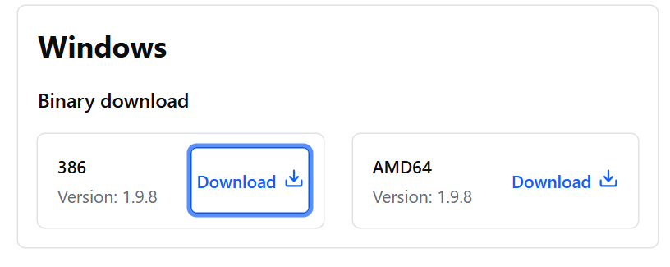

Save the downloaded software in the folder

Example : /d/software

Navigate to Edit system environment variable . (in windows)

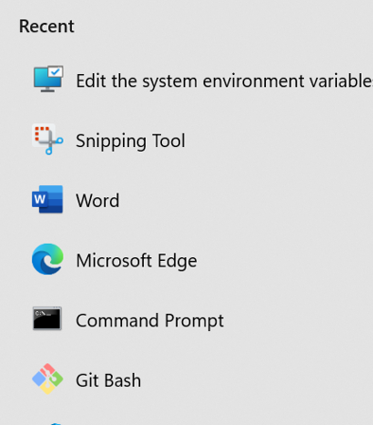

Select environment variable nment variable 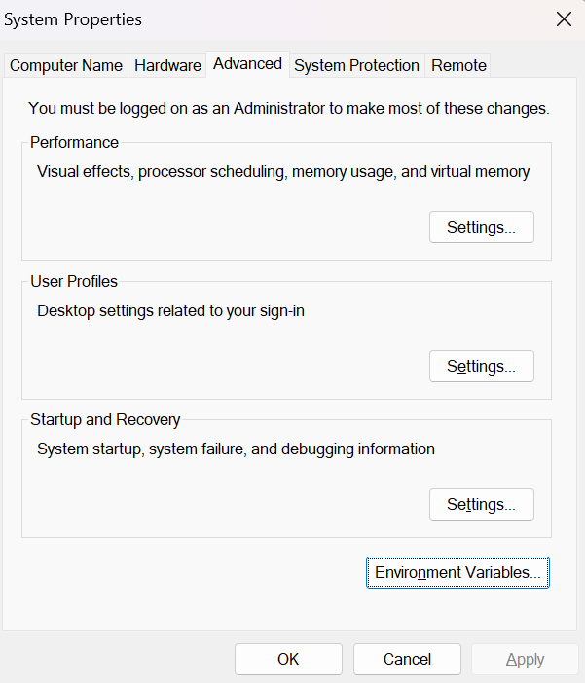

Select path and edit and update the software path in the variables

